**What are Product Recommendation Engines? And the various versions of them?**



Ref - <http://www.emailvendorselection.com/recommendation-engines-for-email-marketing/>

**What is product recommendation?**

A product recommendation is basically a filtering system that seeks to predict and show the items that a user would like to purchase. It may not be entirely accurate, but if it shows you what you like then it is doing its job right.

[Recommender systems](https://en.wikipedia.org/wiki/Recommender_system) have become increasingly popular in recent years, and are utilized in a variety of areas including movies, music, news, books, research articles, search queries, social tags, and products in general. Mostly used in the digital domain, majority of today’s E-Commerce sites like eBay, Amazon, Alibaba etc make use of their proprietary recommendation algorithms in order to better serve the customers with the products they are bound to like. [There are a lot more benefits too](https://www.marutitech.com/recommendation-engine-benefits/), which we cover in the next blogs.

And if set up and configured properly, it can significantly boost revenues, CTRs, conversions, and other important metrics. Moreover, they can have positive effects on the user experience as well, which translates into metrics that are harder to measure but are nonetheless of much importance to online businesses, such as customer satisfaction and retention.

All this is only possible with a recommendations engine. Recommendation engines basically are data filtering tools that make use of algorithms and data to recommend the most relevant items to a particular user. Or in simple terms, they are nothing but an automated form of a “shop counter guy”. You ask him for a product. Not only he shows that product, but also the related ones which you could buy. They are well trained in cross-selling and upselling.

With the growing amount of information on the internet and with a significant rise in the number of users, it is becoming important for companies to search, map and provide them with the relevant chunk of information according to their preferences and tastes.[Chatbots also work on the same working](https://www.marutitech.com/what-chatbots-can-do-for-e-commerce-industry/), but they are little [smarter](https://wotnot.io/templates/) and learn from each product the use views or buys.

Let’s consider an example to better understand the concept of a recommendation engine. If I am not wrong, almost all of you must have used Amazon for shopping. And just so you know, [35% of Amazon.com’s revenue is generated by its recommendation engine](http://www.mckinsey.com/industries/retail/our-insights/how-retailers-can-keep-up-with-consumers). So what’s their strategy?

*Reference: Amazon*

Amazon uses recommendations as a targeted marketing tool in both email campaigns and on most of its websites pages. Amazon will recommend many products from different categories based on what you are browsing and pull those products in front of you which you are likely to buy. Like the ‘frequently bought together’ option that comes at the bottom of the product page to lure you into buying the combo. This recommendation has one main goal: increase average order value i.e., to up-sell and cross-sell customers by providing product suggestions based on the items in their shopping cart or below products they’re currently looking at on-site.

[Amazon uses browsing history](http://rejoiner.com/resources/amazon-recommendations-secret-selling-online/) of a user to always keep those products in the eye of the customer. It uses the ratings and reviews of customers to display the products with a greater average in the recommended and best selling option. Amazon wants to make you buy a package rather than one product. Say you bought a phone, it will then recommend you to buy a case or a screen protector. It will further use the recommendations from the engine to email and keep you engaged with the current trend of the product/ category.

**What are the different types of recommendations?**

There are basically [three important types of recommendation engines](https://www.marutitech.com/recommendation-engine-benefits/):

* Collaborative filtering
* Content-Based Filtering
* Hybrid Recommendation Systems

**Collaborative filtering:**

This filtering method is usually based on collecting and analyzing information on user’s behaviors, their activities or preferences and predicting what they will like based on the similarity with other users. A key advantage of the collaborative filtering approach is that it does not rely on machine analyzable content and thus it is capable of accurately recommending complex items such as movies without requiring an “understanding” of the item itself. Collaborative filtering is based on the assumption that people who agreed in the past will agree in the future, and that they will like similar kinds of items as they liked in the past. For example, if a person A likes item 1, 2, 3 and B like 2,3,4 then they have similar interests and A should like item 4 and B should like item 1.

Further, there are several types of collaborative filtering algorithms:

* **User-User Collaborative Filtering:** Here, we try to search for lookalike customers and offer products based on what his/her lookalike has chosen. This algorithm is very effective but takes a lot of time and resources. This type of filtering requires computing every customer pair information which takes time. So, for big base platforms, this algorithm is hard to put in place.
* **Item-Item Collaborative Filtering:** It is very similar to the previous algorithm, but instead of finding a customer look alike, we try finding item look alike. Once we have item look alike matrix, we can easily recommend alike items to a customer who has purchased any item from the store. This algorithm requires far fewer resources than user-user collaborative filtering. Hence, for a new customer, the algorithm takes far lesser time than user-user collaborate as we don’t need all similarity scores between customers. Amazon uses this approach in its recommendation engine to show related products which boost sales.
* **Other simpler algorithms:** There are other approaches like market basket analysis, which generally do not have high predictive power than the algorithms described above.

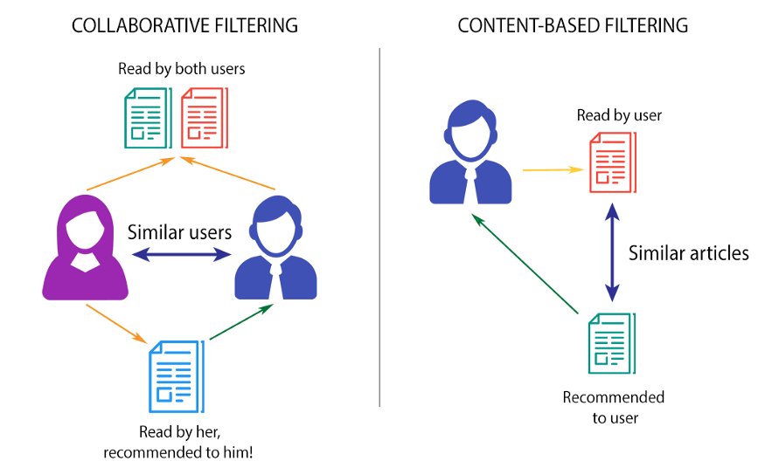

**Content-based filtering:**

These filtering methods are based on the description of an item and a profile of the user’s preferred choices. In a content-based recommendation system, keywords are used to describe the items; besides, a user profile is built to state the type of item this user likes. In other words, the algorithms try to recommend products which are similar to the ones that a user has liked in the past. The idea of content-based filtering is that if you like an item you will also like a ‘similar’ item. For example, when we are recommending the same kind of item like a movie or song recommendation. This approach has its roots in information retrieval and information filtering research.

A major issue with content-based filtering is whether the system is able to learn user preferences from users actions about one content source and replicate them across other different content types. When the system is limited to recommending the content of the same type as the user is already using, the value from the recommendation system is significantly less when other content types from other services can be recommended. For example, recommending news articles based on browsing of news is useful, but wouldn’t it be much more useful when music, videos from different services can be recommended based on the news browsing.

**Hybrid Recommendation systems:**

[Recent research shows](http://dataconomy.com/2015/03/an-introduction-to-recommendation-engines/) that combining collaborative and content-based recommendation can be more effective. Hybrid approaches can be implemented by making content-based and collaborative-based predictions separately and then combining them. Further, by adding content-based capabilities to a collaborative-based approach and vice versa; or by unifying the approaches into one model.

Several studies focused on comparing the performance of the hybrid with the pure collaborative and content-based methods and demonstrate that hybrid methods can provide more accurate recommendations than pure approaches. Such methods can be used to overcome the common problems in recommendation systems such as cold start and the data paucity problem.

[Netflix is a good example of the use of hybrid recommender systems](https://en.wikipedia.org/wiki/Recommender_system). The website makes recommendations by comparing the watching and searching habits of similar users (i.e., collaborative filtering) as well as by offering movies that share characteristics with films that a user has rated highly (content-based filtering).

*Reference:*[*http://dataconomy.com/2015/03/an-introduction-to-recommendation-engines/*](http://dataconomy.com/2015/03/an-introduction-to-recommendation-engines/)

**In conclusion,** there are lot of technical explanations that can be made on the [types of product recommendation engines](https://www.marutitech.com/recommendation-engine-benefits/). All that the users or buyers mostly care are the products and the quality of recommendations that the engine will give. [Such cognitive computing methods](https://www.marutitech.com/cognitive-computing-features-scope/)can take the quality of your recommenders to the next level.